Training Workshop
How to write a paper for
an international journal

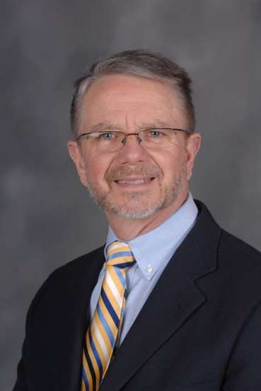
“How to get your research published in top-tier English-language journal”
Lecturer : Professor, Caven S. Mcloughlin
(Kent State University)
Contents
1) Practical tips for maximizing success for journal publication
2) Understanding the editor’s perspective on your journal submission: How to avoid missteps, stumbles & beginner’s mistakes
3) Tips from journal editors for improving your article submission

Apr. 21 (Thurs.), 2016. 15:00~18:00
Bldg. Hoam Hall Room No. 50307

Sponsored by: College of Education
The Institute for Trauma
and Psychological Well-being
Managed by: Professor Lee, DongHun

