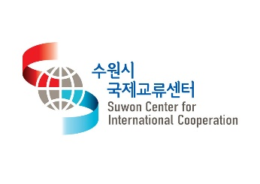
「Suwon Phoenix Exchange Association」
Membership Application
name |  | gender
date of birth
address
Affiliation/
Occupation
Contact | 010-
e-mail
US-related experience
(Work, language, visit, study, etc.)
Motive
Activities you want to do in the association

All of the above is true, and I am applying for participation in the Suwon Phoenix Exchange Association activities as follows.

DD/ MM / 2022
Name (Sign)

Consent to collection and use of personal information
)
Consent to collection and use of personal information
Suwon International Exchange Center may provide personal information to certain organizations in order to verify the accuracy of applicant's personal information in relation to the collection of personal information and handling of personal information. Therefore, in order for an applicant to apply to the Suwon International Exchange Center, he/she must understand and agree to the following privacy policy. This privacy policy applies only to applicants and their personal information.

1. Purpose of collection and use of personal information
Suwon International Exchange Center collects personal information such as name and contact information for the purpose of proceeding with the application and selection process. We inform you that the collected personal information will be used only for the purpose of the applicant selection process and will not be used for any other purpose except for the above purposes.

Do you agree to the collection of personal information? □Agree □Disagree

2. Items of personal information to be collected
Suwon International Exchange Center collects personal information about name, age, address, contact information, e-mail, address, career information, and other information provided by applicants when applying for smooth selection of applicants.

Do you agree to the collection of personal information? □Agree □Disagree

3. Period of retention and use of personal information
The application form and various supporting documents (including electronic form) are preserved, and the personal information of other job applicants is stored for 5 years.
It is stored and immediately destroyed after the expiration of the period.

Do you agree to the collection of personal information? □Agree □Disagree

5. Whether there is a right to refuse consent and whether there are any disadvantages due to refusal of consent
In accordance with Article 15, Paragraph 2, Item 4 of the Personal Information Protection Act, the subject of personal information has the right to refuse to consent to the collection of personal information.

Do you agree to the collection of personal information? □Agree □Disagree

dd/ mm/ 2022

full name (signature)

Dear Chairman of Suwon International Exchange Center

