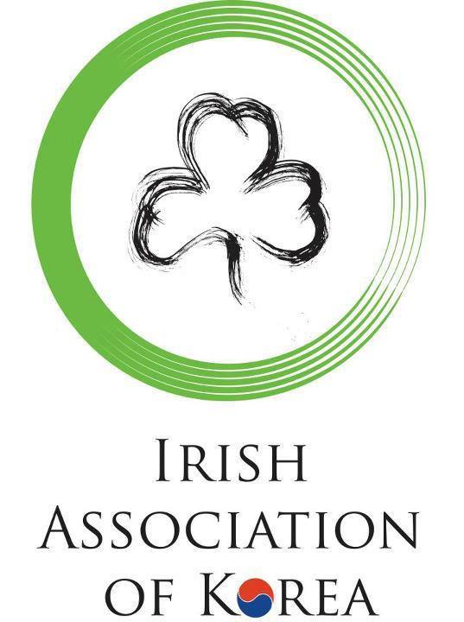

What Ireland Means To Me -Video Competition

Supported by

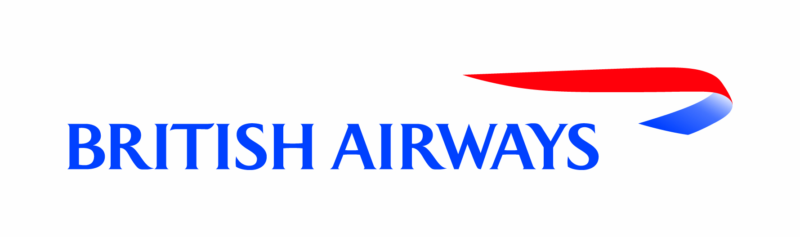
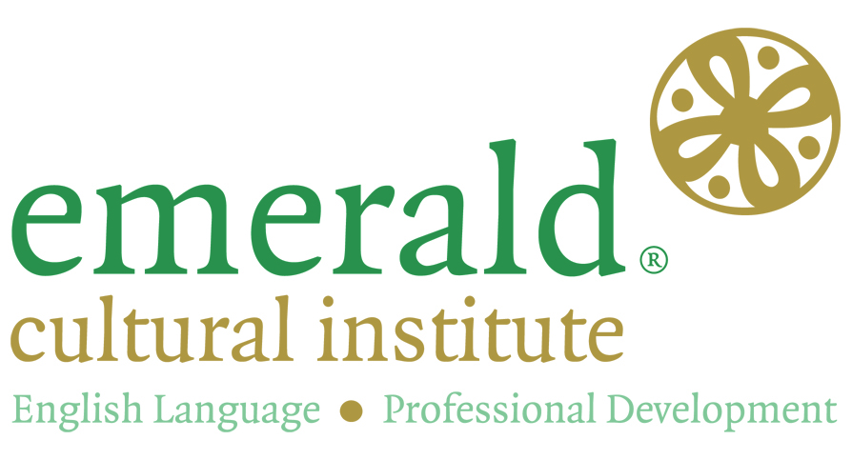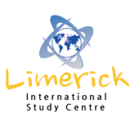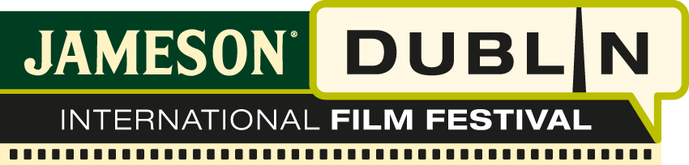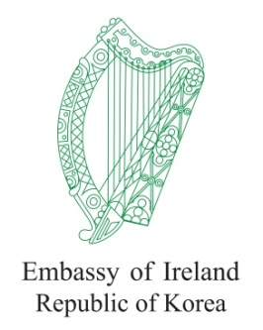

1. Overview
The Embassy of Ireland, South Korea, and The Irish Association of Korea are very proud to announce the launch of the 2015 “What Ireland means to me” Video Competition for university students in Korea.
It also allows contestants to compete for an opportunity to experience Ireland from an educational, cultural, and academic perspective.
The competition seeks to raise awareness about Ireland and the opportunities through Education and Travel that Ireland can offer Korean students.
Participants are invited to make a fun, creative 3 minute long video on the theme “What Ireland means to me”. The entrants are free to share their experiences, impressions and hopes within the context of the topic and are encouraged to film on location in Korea.
First prize will include one month of study in the Emerald Cultural Institute (www.eci.ie), including accommodation, return flights from Korea to Dublin, and spending money. Second prize will receive a two week study stay in Limerick international study centre (www.limerickenglish.com), including accommodation and return flights from Korea to Dublin. The final runner up will receive a cultural prize.

2. Topic
Participants are invited to submit a fun, creative 3 minutes video. The video must be a maximum of 3 minutes with 90 seconds or more in spoken English.

“What Ireland means to me…”
Who are you and why do you want to go to Ireland?

What do you think of when you think of Ireland?

How has Ireland influenced you?

How will this prize be beneficial to you?

3. Rules
- The competition is open to enrolled, full time, under-graduate Korean students.
- The competition is NOT open to exchange students or students who use English as their first language.
- Submissions must be a maximum of 3 minutes with 90 seconds or more spoken in English by the entrant.
- All work must be original work and must NOT have received an award from another contest.
- Follow copyright laws. Be sure that you have permission to use any music, video, or animation that appears in your video.
- No commercial content is permitted.

4. Guidelines
- First, make a video of no longer than 3 minutes. (Videos can be made using phones, digital camera or any digital device)
- Second, upload on www.youtube.com
- Third, fill out the application form available on the Irish Association of Korea website. www.iak.co.kr and send it to irishassociationkorea@gmail.com

5. Application Deadline
January 6th, 2016, 18:00, Korean Local Time.

6. Prizes
Prize | Number of winners | Award
Grand Prize* | 1 | - One month study & accommodation at Emerald language institute in Dublin  - Round trip airfare to Ireland  - Spending money
Runner Up | 1 | - Two weeks tuition (25 lessons per week) and home stay (weekday’s half-board, weekend full-board) for the winning student at Limerick international school. Round trip airfare to Ireland
Highly Recommended | 3 | - Cultural Prizes

* If your lecturer/ professor introduced you to the competition please nominate them on your application form. The Grand prize winner’s professor/lecturer will win two tickets to Ireland’s National Day reception hosted by the Ambassador of Ireland, and his/her University will receive a donation of Irish literature from the Embassy of Ireland.

7. Notices
Prize winning entries may be utilized by the Irish Association of Korea for promotion of the Association and its activities. Prizes will be forfeited if the video is found to have been plagiarized or if it has won an award in another competition.

8. Judging Criteria
Judges will take the following into consideration:
- Understanding of contest theme
- Creativity
- Video Quality
- Narration
- Overall presentation
Entries will be adjudicated on by the I.A.K, Embassy of Ireland and the Jameson Dublin Film Festival.

