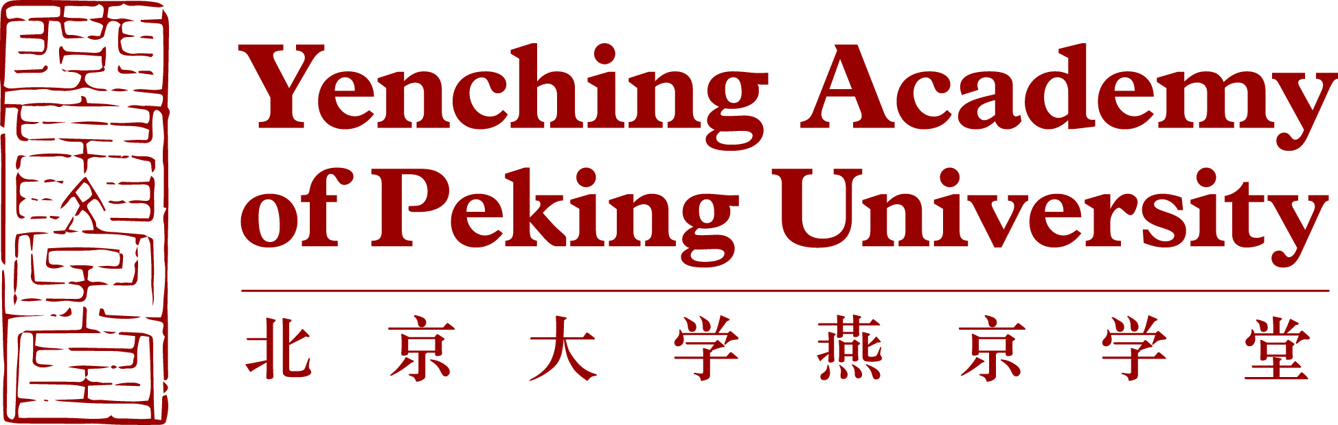

Recommendation letter for _______________ (applicant’s full name)
Recommendations are to be provided by professors, academic advisors, or other individuals in a position to comment on the applicant's achievements, character, and potential. Recommenders should complete the following fields and append a separate letter of recommendation to this cover page. Please refer to the below section, “Guidance for Letters of Recommendation,” when writing your letter.

Recommender Information | Name
 | Organization/Company
 | Job Title
 | Phone Number
 | Formal University/Company Email Address
 | Preferred Email Address
 | Relationship with the Applicant
Applicant Overview
Among the undergraduate students at a similar stage of study whom you have known in recent years, how would you rate the applicant?

(Please rate based on a scale of 0-100, with 0 being lowest and 100 being highest)
Academic ability (0-100)
Learning ability (0-100)
Motivation for this program (0-100)
Maturity/ability to work or study with others (0-100)
Leadership potential (0-100)
Guidance for Letters of Recommendation
The Yenching Academy Admissions Committee would like to thank recommenders in advance for their candid evaluations of applicants for the Master’s in China Studies program. Letters of recommendation carry significant weight in the admissions process. Recommendations are to be provided by professors, academic advisors, or other individuals in a position to comment on the applicant's achievements, character, and potential.

In addition to two letters of recommendation, the Admissions Committee will be reviewing the applicant’s academic transcript, CV, and personal statement articulating reasons why the program will enhance his/her career.

Our mission is to ensure that international leaders in a variety of fields have a broad and rich understanding of China. We are interested in your evaluation of the applicant's academic abilities, personal qualities, leadership potential, defined as you like, and suitability for the program. Thus, applicants’ personal qualities are as important as academic abilities and professional experience.

A successful candidate not only has an outstanding academic record, high intellectual ability, and demonstrated leadership skills, but also has a strong moral character and sense of social responsibility.

The Admissions Committee will be grateful if letters of recommendation could speak to the above qualities and include the following criteria:
- Applicant’s full name
- How long recommender has known the applicant and in what capacity
- Applicant’s strengths and ability to complete the Yenching Academy Master’s in China Studies program
- Applicant’s potential for becoming a responsible and successful leader

Letters of recommendation should be uploaded to the Yenching Academy online application portal where possible. Candidates will first enter recommender requests in their online application; the system then send an email request to recommenders with instructions for submission.

The Yenching Academy prefers recommenders to upload their letters of recommendation on official university/company letterhead in .pdf form. If for any reason recommenders are unable to upload or copy/paste their letters online, they may email the .pdf files directly to yca-submsissions@pku.edu.cn.

Please note that applicants of Partner Universities will give their recommenders university-specific instructions for submission. Recommenders of Partner University applicants will not upload their letters of recommendation to the Yenching Academy online application portal. In most cases, recommendation letters should be sent directly to the Partner University’s listed contact. The applicant is responsible for ensuring that recommenders understand where letters should be sent.

The Admissions Committee is greatly appreciative to recommenders for taking the time and consideration to share their evaluation and judgment of applicants.

Recommenders may contact the Yenching Academy at yca-admissions@pku.edu.cn with any questions or concerns they have regarding the admissions process.

