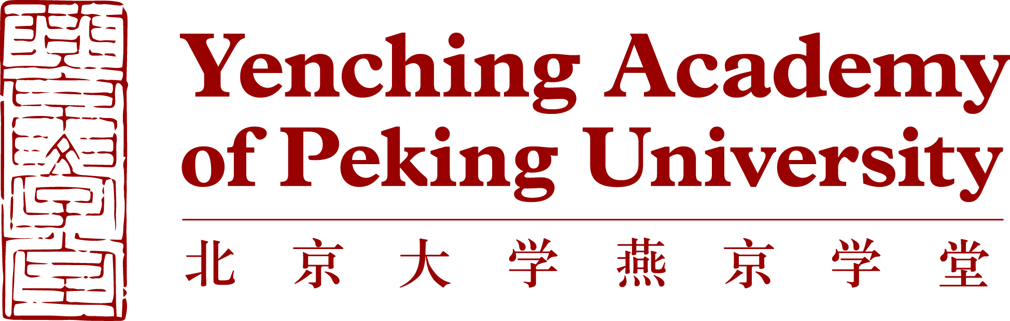

Biographical information
Background Information | Family Name (as shown on passport)
 | Middle Name (as shown on passport)
 | Given Name (as shown on passport)
 | Sex
 | Date of Birth (dd/mm/yyyy)
 | Country/Region of Birth
 | Country/Region of Citizenship
Language | Native Language
 | Other Languages (please specify level of fluency) | Language 1
 |  | Language 2
 |  | Language 3
Correspondence Address | Current Postal Address (where you currently reside)
 | Address
 | City
 | State/Province
 | Zip/Postal Code
 | Country
 | Permanent Mailing Address (if different from current address)
 | Address
 | City
 | State/Province
 | Zip/Postal Code
 | Country
Other Contact Information | Email Address (preferred)
 | Secondary Email Address
 | Skype Username
 | Primary Phone Number
 | Secondary Phone Number

Academic Background
Academic  Background | University
 | Location (city, state, country)
 | School or Department
 | Major
 | Second Major (if any)
 | Minor (if any)
 | Month and Year of Graduation (or expected)
 | Degree
Current GPA (out of 4.0)
If your university uses a different grading system, please indicate the grading scale used and your standing within this scale.
Recommender 1 | Name
 | Organization/Company
 | Job Title
 | Phone Number
 | Formal University/Company Email Address
 | Relationship with the Applicant
Recommender 2 | Name
 | Organization/Company
 | Job Title
 | Phone Number
 | Formal University/Company Email Address
 | Relationship with the Applicant
Study Plan
Item | Details
Degree | Name of Degree | Master of Chinese Studies
 | Preferred Concentration | Please Choose (√)one of six concentrations  ○Philosophy and Religion  ○History and Archaeology  ○Literature and Culture  ○Economics and Management  ○Law and Society  ○Public Policy and International Relations
 | Year of Entry
Language Requirement | IELTS
 | TOEFL
 | Cambridge
 | CEFR
 | • English Proficiency Test Score (for those whose first language is not English or are not graduating from an English-speaking university)

Personal Statement
The personal statement, not to exceed 750 words in English, should include a personal introduction and reasons why you wish to be a Yenching Scholar.

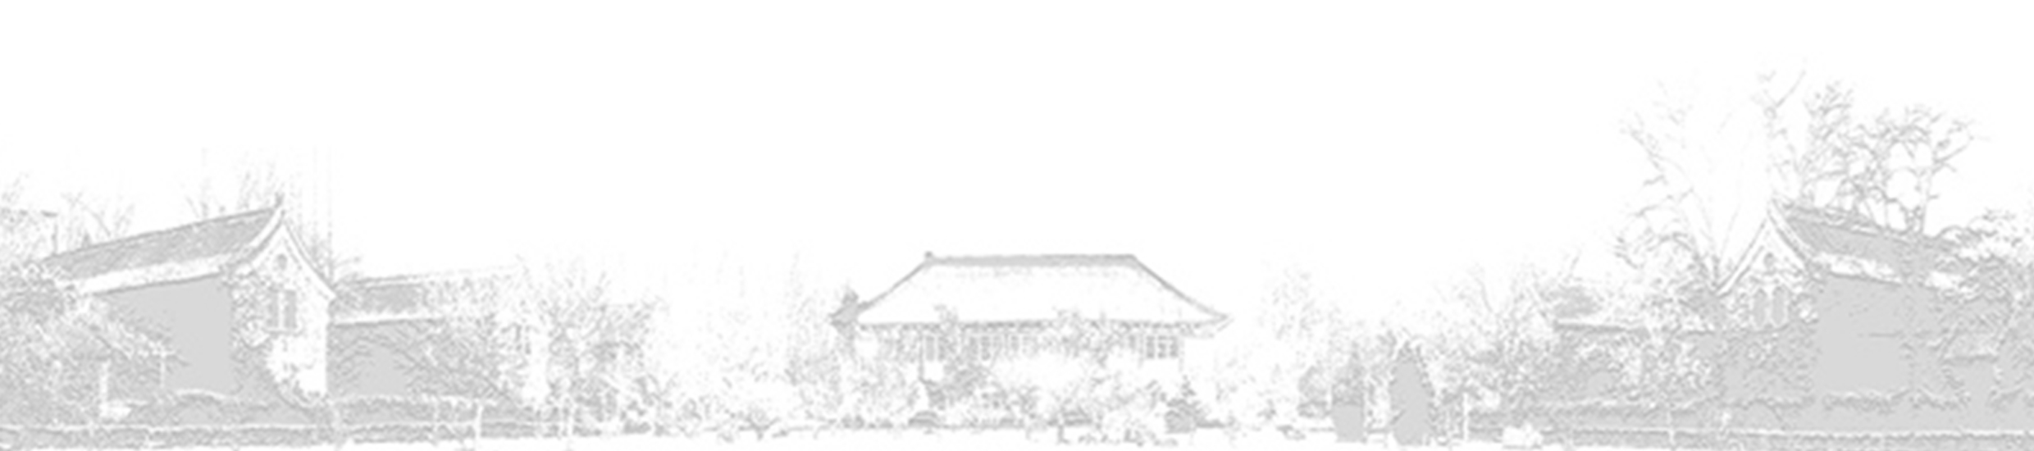
Your application package should include: (1) completed application form; (2) scanned copy of your most recent official transcript; (3) English proficiency test score report; (4) personal statement; and (5) curriculum vitae.

Thank you for applying to the Yenching Academy of Peking University.

